 **Year 8 - Humanities and Social Sciences 2024**

**Assessment 1 A - Parts A and B (10%)**

**Inquiry Task**

**Geological Hazards and Earthquakes**

**Name: _______________________________**

|  |  |  |  |
| --- | --- | --- | --- |
| **Your Target** | **Mark** | **Percentage** | **Weighting** |
| **Inquiry Booklet**  **/80**  **Presentation**  **/60** | **Inquiry Booklet**  **/80**  **Presentation**  **/60** |  | **10%** |
| **TOTAL MARKS:**  **/140** | | | |

**Date Due: Week 9, Term 1.**

**Date:_____________________**

**Section One (PART A): Inquiry Process**

Investigate the causes and effects of a previous earthquake.

* Choose an earthquake from the list provided.
* Use the inquiry booklet to record your information, Using 6-8 focus questions.
* You will have five lessons to conduct your inquiry.
* Remember to include a bibliography. A range of references must be used.
* Complete the PMI Chart. This is to evaluate the task.
* Make sure that your research focuses on what must be included in your presentation (list provided below).

**Section Two (PART B): Presentation**

**(Inquiry Task – Communicating and Reflecting)**

Present your research findings as a presentation. This can be completed as a PowerPoint, Poster, Video or Prezi etc.

**Your presentation must include:**

* Date and location of the earthquake (include map).
* Possible explanations as to why the earthquake occurred – i.e. Plate boundary / hotspots etc.
* Epicentre and Magnitude of the earthquake
* Damage the earthquake caused. *(towns damaged and square kilometre radius from epicentre, fatalities etc.)*
* Effects – Social, Economic, environmental and cultural.
* Major resulting effects (eg. Tsunami, landslide, fires, etc.)
* Could the damage and fatalities have been reduced
* Additional Information on your chosen Earthquake
* Likelihood of another earthquake occurring in the same location, and if earthquakes can be predicted in this region.
* What to include in an emergency kit / bug out bag if you were living in this location when another earthquake event occurs.

**Section Three (Part C): Validation Questions**

*Answer validation questions in relation to your research inquiry. This part will be completed in conjunction with a test later in the term.*



**Significant Historical Earthquakes**

*Choose one from the list below of significant earthquakes that have occurred around the world.*

* Sumatra Earthquake (2012)
* Maule (Chile) Earthquake (2010)
* Tohoku Earthquake (2011)
* Valdivia Earthquake (1960)
* Newcastle Earthquake (1989)
* Northridge, California (1994)
* Tonga Earthquake (2022)
* Christ Church Earthquake (2011)

**Useful Websites**

*Geoscience Australia-* [**https://earthquakes.ga.gov.au/**](https://earthquakes.ga.gov.au/)

*National Science Forum-* <https://www.iris.edu/hq/retm>

*Australian Geographic* <https://www.australiangeographic.c> m.au/topics/science environment/2011/03/earthquakesthe-10biggest in-history/

*United States Geological Survey* <https://www.usgs.gov/programs/earthquake> hazards/science/20-largestearthquakesworld

*Encyclopedia Britannica* [*https://www.britannica.com/list/6-deadliest*](https://www.britannica.com/list/6-deadliest) *earthquakes*

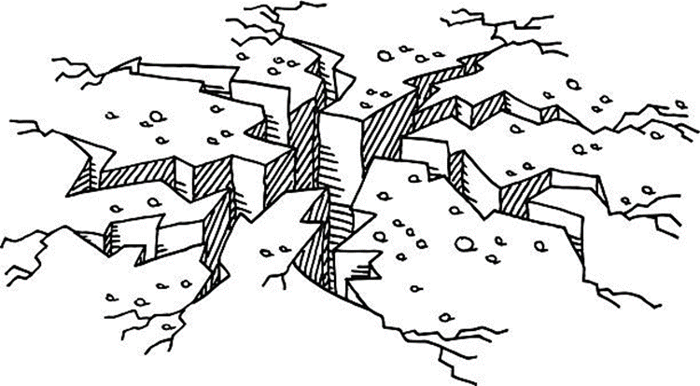

**Inquiry Process Booklet**

Teacher to tick when completed ÿ

Date:­­

Teacher Initial:

Which significant earthquake did you choose for this inquiry?

________________________________________________________

What do I already know about the topic?

1. **Complete the brainstorm below, focusing on what you know about your chosen earthquake and geological hazards.**

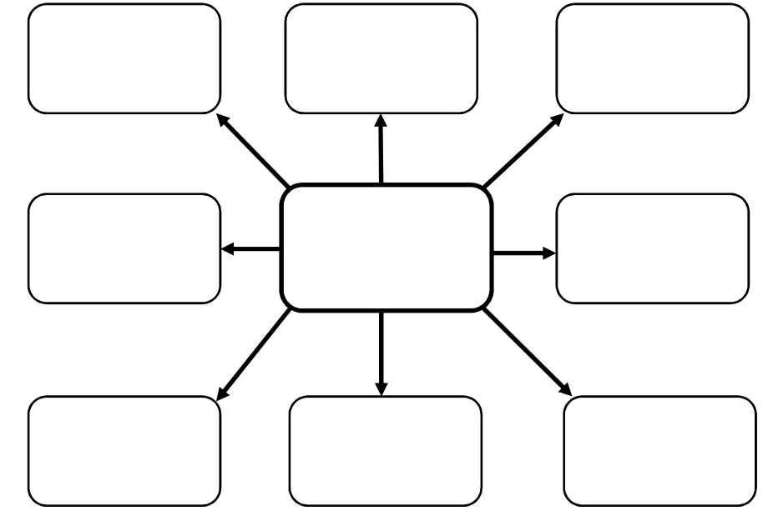

Teacher to tick when completed ÿ

Date:­­

Teacher Initial:

**Complete the KWL below on earthquakes;**

|  |  |  |
| --- | --- | --- |
| K | W | L |
| What do you already **know** about the topic? | What do you **want** to know about the topic? | What have you **learned** about the topic? |
|  |  |  |

1. **Note taking sheet**

**Focus Question 1**

|  |
| --- |
|  |

**Key points from information sources and reference details**

|  |
| --- |
|  |
| Source(s): |

**Focus Question 2**

|  |
| --- |
|  |

**Key points from information sources and reference details**

|  |
| --- |
|  |
| Source(s): |

**Focus Question 3**

|  |
| --- |
|  |

**Key points from information sources and reference details**

|  |
| --- |
|  |
| Source(s): |

**Focus Question 4**

|  |
| --- |
|  |

**Key points from information sources and reference details**

|  |
| --- |
|  |
| Source(s): |

Teacher to tick when completed ÿ

Date:­­

Teacher Initial:

**Focus Question 5**

|  |
| --- |
|  |

**Key points from information sources and reference details**

|  |
| --- |
|  |
| Source(s): |

Teacher to tick when completed ÿ

Date:­­

Teacher Initial:

**Focus Question 6**

|  |
| --- |
|  |

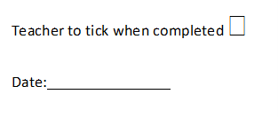**Key points from information sources and reference details**

|  |
| --- |
|  |
| Source(s): |

**Focus Question**

|  |
| --- |
|  |

**Key points from information sources and reference details**

|  |
| --- |
|  |
| Source(s): |

Teacher to tick when completed ÿ

Date:­­

Teacher Initial:

**Focus Question**

|  |
| --- |
|  |

**Key points from information sources and reference details**

|  |
| --- |
|  |
| Source(s): |

Teacher to tick when completed ÿ

Date:­­

Teacher Initial:

**Presentation Checklist**

*Presentations can be created in whatever way you choose, including PowerPoints, Posters, Movies, Prezi, Brochure etc.*

**Title**

**Date and location of Earthquake (include map)**

**Explanation as to why earthquake may have occurred** (including type, plate boundary etc.)

**Description of the epicentre and magnitude of the earthquake** (including Richter scale)

**Description of Damage from the earthquake** (include towns, and square meterage).

**Description of the Effects of the earthquake** (social, economic, human and environmental)

**Description on any major resulting effects** (i.e. tsunami, landslides, fires etc.)

**Proposition on if the damage, fatalities and fallout could have been reduced.**

**Interesting Facts and Additional Information**

**Likelihood of earthquake reoccurring in same location and if it can be predicted.**

**Description on how to prepare form an Earthquake (in same location).**

**Presentation includes images and a map**

**Presentation is engaging and visually appealing**

**Submit Presentation to teacher, either via email, connect or by handing in a hard copy along with the inquiry booklet.**





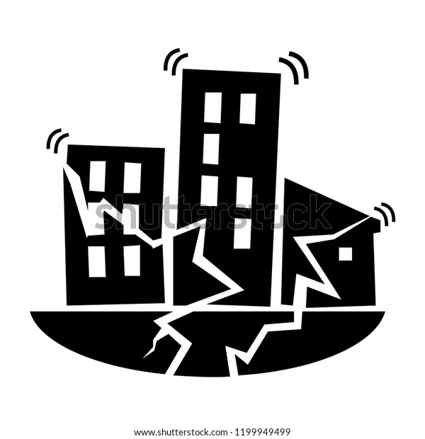

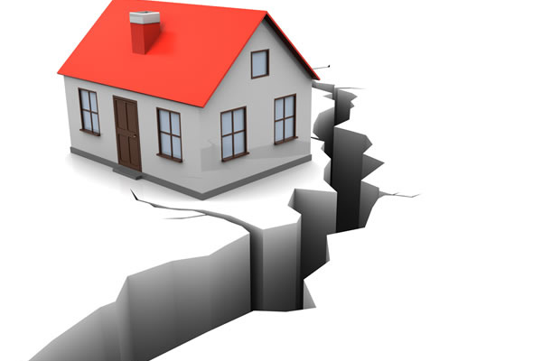

1. **Complete the PMI chart below (THE TASK)**

Teacher to tick when completed ÿ

Date:­­

Teacher Initial:

|  |  |  |
| --- | --- | --- |
| P – Plus | M - Minus | I - Interesting |
| Positives (Pluses) about the task | Negatives (Minuses) about the task | Interesting parts of the task |
|  |  |  |

|  |  |  |  |  |  |
| --- | --- | --- | --- | --- | --- |
| **Author** | **Date last updated** | **Title of Webpage** | **Date accessed** | **HTTP** | |
|  |  |  |  |  | |
|  |  |  |  |  | |
|  |  |  |  |  | |
|  |  |  |  |  | |
|  |  |  |  |  | |
|  |  |  |  |  | |
| **Author** | **Date of Publication** | **Title of Book** | **Publisher** | | **Place of Publication** |
|  |  |  |  | |  |
|  |  |  |  | |  |
|  |  |  |  | |  |

1. **Reference recording sheet**

*Please note that in order to obtain full marks you must submit a formal bibliography, the table below is only for recording your references as you are researching.*

Teacher to tick when completed ÿ

Date:­­

Teacher Initial:

Teacher to tick when completed ÿ

Date:­­

Teacher Initial:

Teacher to tick when completed ÿ

Date:­­

Teacher Initial:

Teacher to tick when completed ÿ

Date:­­

Teacher Initial:

Teacher to tick when completed ÿ

Date:­­

Teacher Initial:

Teacher to tick when completed ÿ

Date:­­

Teacher Initial:

Name: __________________________ Year 8– Geography - Task 1 – Earthquake Inquiry Task (5%)

DETAILED MARKING GUIDE/RUBRIC

|  |  |  |  |  |  |  |  |
| --- | --- | --- | --- | --- | --- | --- | --- |
| **Task â &**  **Marks Allocation à** | **5 - 6** | | **3 – 4** | | **0 - 2** | | **Subtotal** |
| **Brainstorm** | Clear evidence of brainstorming of ideas for the product and the task. Comprehensive detail and a wide range of ideas is included. | | Some evidence of brainstorming of ideas for the product and the task. Some detail is included, and a range of ideas is included. | | Little evidence of brainstorming ideas about the product or the task. Lacks detail and range of ideas. | | /6 |
| **KWL** | Comprehensive detail is used in each section of the KWL, which relates clearly to the chosen earthquake. Has included detailed and well-thought-out possible focus questions. | | Detail has been used in most sections of the KWL and information mostly relates to the earthquake. Has included possible focus questions however some may be lacking in detail. | | Little or no detail has been used in all sections of the KWL and it may not relate to the significant individual. Has not included suitable focus questions. | | /6 |
| **Focus questions** | Devises a set of 6 minimum focus questions (5 marks)  More (6 marks) which clearly address the information required for the earthquake presentation. | | Devises a set of simple questions which identifies some information needed for the earthquake presentation. | | Lists a few simple closed ended questions which identify limited information needed for the earthquake presentation. | | /6 |
|  | **25-30** | **20-24** | **15-19** | **10-14** | **5-9** | **0-4** |  |
| **Note taking** | Provides very detailed accurate notes (in full sentence form) which address the research areas in detail.  Uses evidence from a range of relevant and reliable sources. | Provides detailed accurate notes which address the research areas.  Uses evidence from a range of relevant sources. | Provides notes that are somewhat detailed and accurate which addresses some of the research areas.  Uses evidence from a range of sources which are mostly relevant. | Provides notes that have adequate detail and accuracy which attempts to address the research areas.  Uses evidence from a few sources which are somewhat relevant. | Provides notes have limited detail and accuracy, which makes a limited attempt to address the research areas.  Uses evidence from a small range of sources, which are mostly irrelevant and/or inaccurate. | Notes have insufficient detail and do not address the research detail.  Uses little evidence from limited sources which have little or no relevance.  No notes are submitted (0) | /30 |
|  | **5 - 6** | | **3 – 4** | | **0 - 2** | |  |
| **PMI Chart** | Presents a very detailed and comprehensive chart, through the use of a well-structured PMI Chart. Comprehensive detail is used in each section of the PMI chart, which relates clearly to the task and the key areas. Includes detail on task and topic. | | Presents a less detailed PMI chart. Less comprehensive reference to key areas. Some sections are incomplete or the chart is not finished, with sections missing, including basic information on task and/or topic. | | Presents a generalised plan and/or limited chart. Limited references are made to key areas. Sections are missed.  No KWL Chart is submitted (0) | | /6 |
|  | **6 – 8** | | **3 - 5** | | **0 - 2** | |  |
| **Bibliography** | Submits a formal bibliography which collects information from a comprehensive number of sources incorporating ethical protocols which correctly follow the referencing technique approved by the school. | | Submits a formal bibliography that includes a smaller range of sources which mostly follow the referencing technique approved by the school.  Has used a variety of sources however has only recorded these in the reference recording sheet (3) | | Bibliography includes a limited list of sources which may follow the referencing technique approved by the school. | | /6 |
|  |  | |  | | **Part A: total** | | /80 |
| Inquiry Process Feedback: | | | | | | | |

Name: __________________________ Year 8 - Geography: Task 1 – PART B Presentation (4%

DETAILED MARKING GUIDE/RUBIRC

|  |  |  |  |  |  |
| --- | --- | --- | --- | --- | --- |
| **Task â &**  **Marks Allocation à** | **8-10** | **5-7** | **2-4** | **0-2** | **Subtotal** |
| **Background** | Provides a very detailed description on the background of the chosen earthquake. The description includes the date and location of the earthquake, with reference to a map. As well as information on the epicentre and magnitude of the earthquake. | Provides a detailed description on the background of the chosen earthquake. The description includes the date and location of the earthquake, with reference to a map. As well as information on the epicentre and magnitude of the earthquake. | Provides a brief description on the background of the chosen earthquake. The description includes the date and location of the earthquake, with reference to a map. As well as information on the epicentre and magnitude of the earthquake. | Provides little or no description on the background of the chosen earthquake. The description includes the date and location of the earthquake, with reference to a map. As well as information on the epicentre and magnitude of the earthquake. |  |
| **Causes** | Provides a very detailed description on the possible causes of the chosen earthquake. The description addresses information regarding the type of earthquake, hot spot and plate boundaries etc. | Provides a detailed description on the possible causes of the chosen earthquake. The description addresses information regarding the type of earthquake, hot spot and plate boundaries etc. | Provides a brief description on the possible causes of the chosen earthquake. The description addresses information regarding the type of earthquake, hot spot and plate boundaries etc. | Provides little or no description on the possible causes of the chosen earthquake. The description addresses information regarding the type of earthquake, hot spot and plate boundaries etc. |  |
| **Damages** | Provides a very detailed description on the damage the earthquake caused, including the towns, social, economic & environmental effects, and major resulting effects. | Provides a detailed description on the damage the earthquake caused, including the towns, social, economic & environmental effects, and major resulting effects. | Provides a brief description on the damage the earthquake caused, including the towns, social, economic & environmental effects, and major resulting effects. | Provides little or no description on the damage the earthquake caused, including the towns, social, economic & environmental effects, and major resulting effects. |  |
| **Preparation** | Provides a very detailed description on the likelihood of the chosen earthquake reoccurring, as well as how one could prepare for another earthquake in the same location. | Provides a detailed description on the likelihood of the chosen earthquake reoccurring, as well as how one could prepare for another earthquake in the same location. | Provides a brief description on the likelihood of the chosen earthquake reoccurring, as well as how one could prepare for another earthquake in the same location. | Provides little to no description on the likelihood of the chosen earthquake reoccurring, as well as how one could prepare for another earthquake in the same location. |  |
|  | **5-6** | **3-4** | **1-2** | **0** |  |
| **Additional Information** | Provides very detailed additional information on the chosen earthquake | Provides detailed additional information on their chosen earthquake. | Provides limited additional information on their chosen earthquake. | Provides no additional information on their chosen earthquake. |  |

|  |  |  |  |  |  |
| --- | --- | --- | --- | --- | --- |
|  | **5-6** | **3-4** | **1-2** | **0** |  |
| **Use of examples/supporting evidence** | Has selected supporting evidence/examples that effectively reinforce the written description of life and legacy of the chosen earthquake. | Has selected supporting evidence/examples that mostly reinforces the written description of the chosen earthquake. | Has selected a narrow range of supporting evidence/examples that do not necessarily reinforce the written description of the chosen earthquake. | Has not provided any supporting evidence/ examples. |  |
|  |  | **6-8** | **3-5** | **0-2** |  |
| **Presentation-Visual** |  | Presentation is visually engaging. Displays a high level of detail and presents information about the earthquake to a high standard. It is clear that a lot of time and thought is put into the presentation. | Presentation is engaging. Displays a satisfactory level of detail and overall presents information about the earthquake to a satisfactory standard. Some time and thought is put into the presentation. | Presentation is somewhat engaging. Displays limited amount of detail and presents little information about the earthquake. Little time or thought is put into the presentation. |  |
| **Part B - TOTAL** | **/60** |
| **Presentation Feedback** | | | | | |
| **Overall Assignment Feedback** | | | | | |